***MATLAB***

MATLAB COMMANDS:

1. Clear all: It clears all the variables

2. clc: It clears the command window

3.MATLAB only does operations on matrices.

3. A=[1,2]-> gives row vector

4. A=[1;2]-> gives column vector

Matlab window

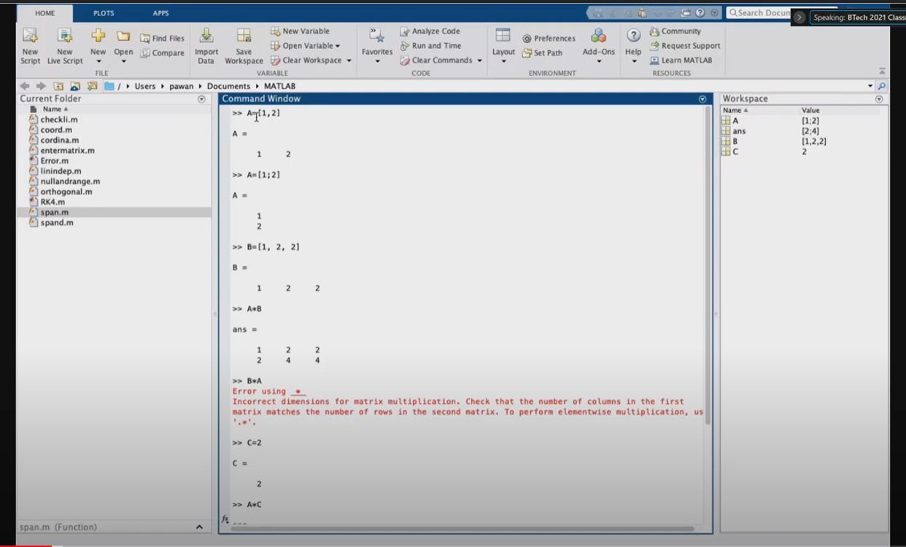

Q. How to find the roots of a polynomials?

Ans-

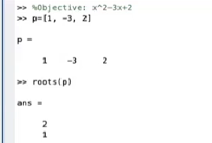

P is the matrix of coefficients. The coefficient matrix should be a vector and not a matrix.

*If A is a matrix then command poly(A) gives characteristic polynomial for matrix A.

* Command eig(A) gives the eigen values of A directly.

* [v d]=eig(A) command gives v matrix which has its columns as the eigen vectors

*d is the diagonal matrix having eigen values of A as entries.

* det(A) gives the determinant of matrix A.

*inv(A) gives the inverse of A.

* checklin function is used to check if a given set of vectors is linearly independent or dependent.

* varargin variable is used when the no. of arguments to be entered within the function is not specified.

* length(varargin); is used to know how many vectors are given as input.

* for i=1:n means the statement under for loop will be until the value of i becomes n.

* b=varargin{i}’ converts the ith row vector into column vector.

* A=[A b] will keep on inserting more column vectors b into the matrix A.

* display prints a statement on screen written within (‘’).

Ex- display(‘I am a man’) will print I am a man on the output screen.

* end command terminates the statement.
* Program to check linearly dependence of a given set of vectors:
* 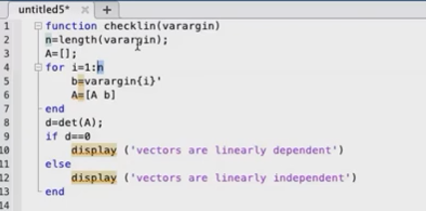

* Program to check if a given set of vectors are orthogonal or not

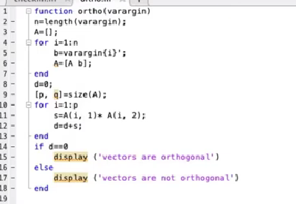

* Program to check if a given set of vectors are orthogonal or not

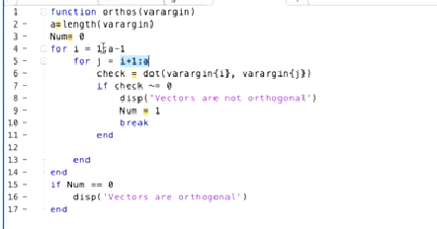This is another way.

*Program for Gram schmidt process:

